OPEN LOOP TRACKING OF SUN
1 Introduction
1.1 Purpose of Manual
This manual will summarize the dish movement to show how open loop tracking will be achieved in a StarGen system.
There is an accompanying spread sheet that contains further information that complements this document. The name of the spreadsheet is OpenLoopTracking.xslx.
2 Number system
The dish is mounted using a polar mount with an actuator to control the declination angle and a brushless DC motor to change the ascension angle. By choosing the origin to be the center of the rotation pivot point will help simplify computing the location of the end of the beam. This will result in a negative height when the dish is facing in a northerly direction.
3 Equations to translate radial into three dimension
{North-South} = R * sin(tilt) *cos(rotation angle)
{East-West} = R * sin (rotation angle)
Height = (R² - {North-South}²⁻ {East-West}²)^{1/2}
Where, R is the radius measured from the pivot point to tip (these equations are calculating the position of the center of the beam where the upper sense board is mounted to.
4 Inclinometer
Dual axis inclinometer that essential checks level in two orthogonal planes with respect to gravity. The inclinometer measures +/- 90 degrees to level. The data sheet shows the use is for 360 degree vertical orientation measurement.
To convert the dish position to what the inclinometer would see, graph each axis with respect to height. The plane for each axis is essentially the slope of the line at any point. Graph in 5.3 for tilt angle and graph in 5.2 for east-west level.
The east west axis is close to level at solar noon and solar midnight. As the dish is at 6 am or 6pm the slope of the line switches from +90 to -90. 6 am or 6 pm would not be a good point to check the east west axis inclinometer.
The north south axis is ideally the tilt angle of the dish. In an actual dish the data is distorted as it dish gets away from level position in the east west axis. The data sheet claims only a 4% cross axis affect. In practice it appears to be much more. Observed data at North Ridgeville was 20%
5 Plots of ideal dish
The plots in chapter 5 are all using a tilt angle of 49 degrees (equinox position for latitude of 41 degrees) and a beam length of 8 feet.
5.1 North/South versus East/West
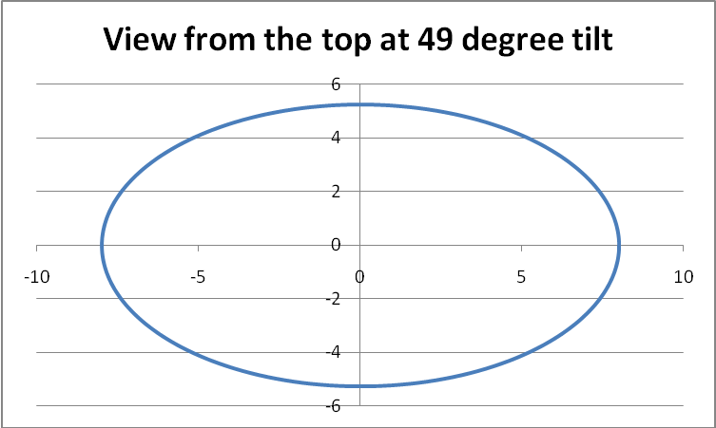
The ellipse has a major diameter in the east/west direction of 2 times Radius of beam, 16 feet. The minor diameter in the north/south direction is 2 times Sin(tilt angle), is 5.25 feet.
5.2 East/West versus height
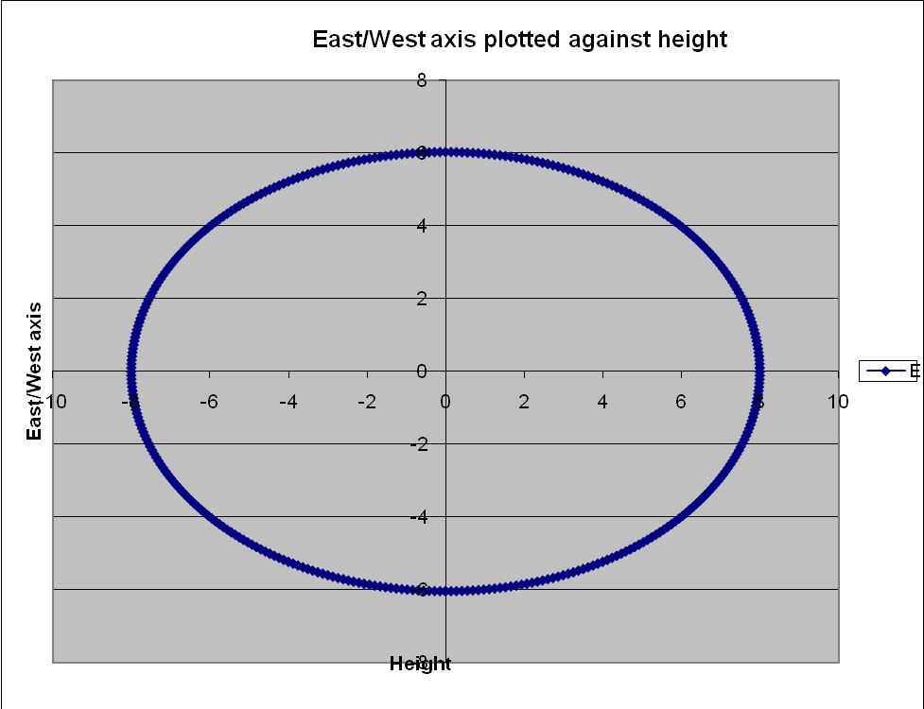
The ellipse is similar to top view, but minor axis is twice the radius of the beam times tan(tilt), tan(49) = 1.15 *north-south, 6.04 feet.
5.3 North/South versus height
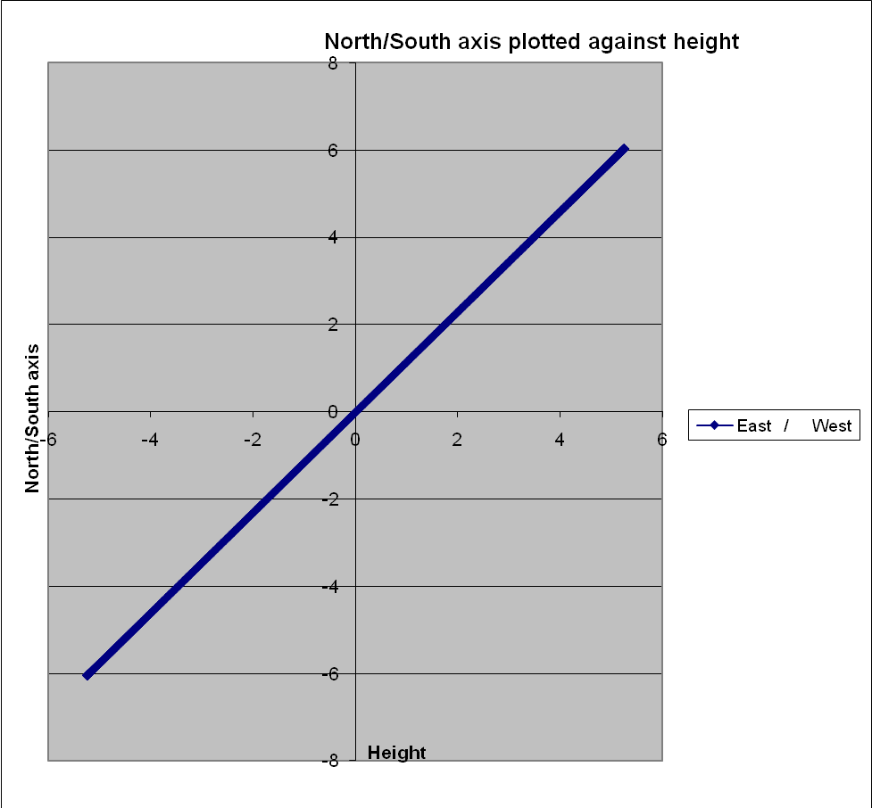
A line that slopes at the tilt angle, example above for 49 degrees, height reaches 6.04 feet above the pivot point.
6 Correcting for errors in installation
After installation need to measure the actual tilt of the beam and determine if there is any error on the polar north/south.
To correct for improper tilt angle is just a straight offset to add to the tilt angle of any given day.
To correct for polar mount not being true north/south is slightly more complicated. The first adjustment is to know how many degrees off of true north/south line the pole is. The solar noon will need to be adjusted 4 minutes per degree that it is off. The tilt angle will need to be offset as shown below:
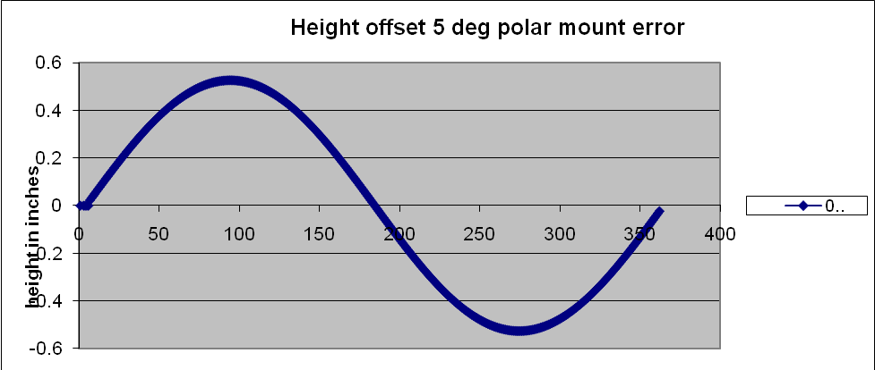
The above graph, x axis is in degrees, 180 degrees is solar noon, 90 degrees is 6 am, and 270 degrees is 6 pm. To get an accurate adjustment of the height will require computing the sine of the time with time converted into degrees. Further calculation will be necessary to convert to motor extension or motor pulses.

7 Solar noon
Solar noon will need to have a formula to compute the solar offset time. Actual solar noon will be compared to computed time. Computed time accuracy should be within 15 seconds. Day to day the solar noon moves from 1 second to 30 seconds. For times when the sun does not come out for several days will need the computed solar noon offset to keep the dish close to actual solar noon. As long as the sun comes out sometime during the day the computed value can be compared to the actual.

8 Dish geometry
The figure below shows the dimensions of the rotational part of the dish (use the law of cosines to find the angle of the different triangles, used in the attached spreadsheet to find motor shaft extension for different tilt angles. Note, the equinox position is when the beam forms a right angle with respect to the polar mount.
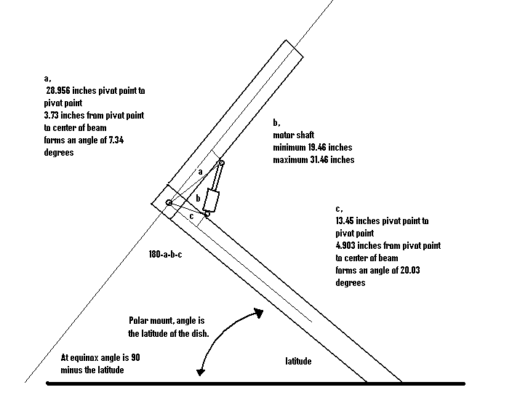
9 Open loop control of the dish
To be completed.

